EXPERIMENT 7

DQL COMMANDS (COLLEGE SCHEMA)

Aim:

* Display student id and marks from the student table.
* Display faculty id and name from the faculty table.
* Display who got grade A.
* Display whose marks are less than 50.
* Display the female students whose marks are between 50 to 60.
* Delete the failed students.
* Display activity id and name using object.
* Display student id, faculty id using course name condition with object.
* Select department name starting from ‘c’ and faculty name ending with ‘a’.
* Select activity having characters between ‘ck’.
* Group by faculty id and display.
* Display the students list whose grade is A using having.
* Display the faculty list who are teaching DM.
* Apply aggregate functions in student marks - max, min, sum, count, avg.
* Display student id and marks from the student table.
* Display faculty id and name from the faculty table.

C:\Users\sukha\OneDrive\Desktop\Telegram Desktop\Activity1\activity1\s_16.jpg

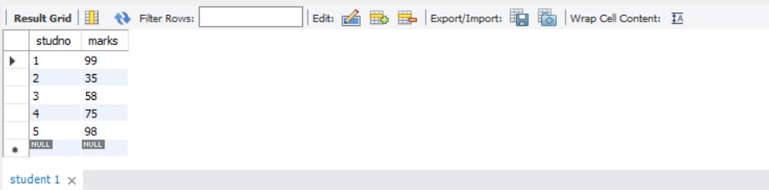

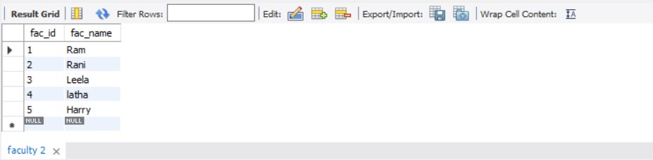

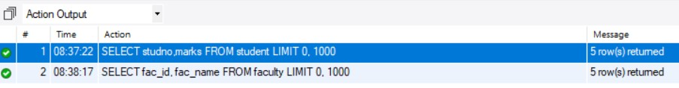

* Display who got grade A.
* Display whose marks are less than 50.
* Display the female students whose marks are between 50 to 60.

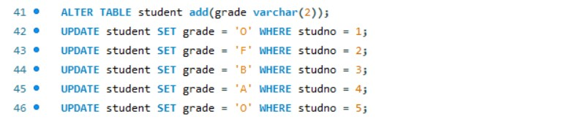

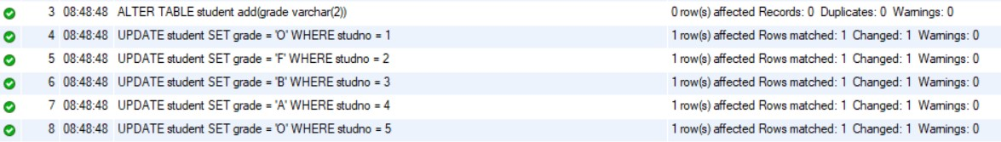



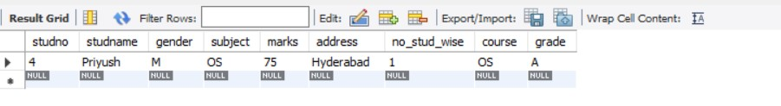

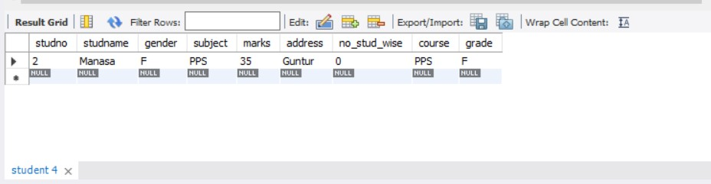

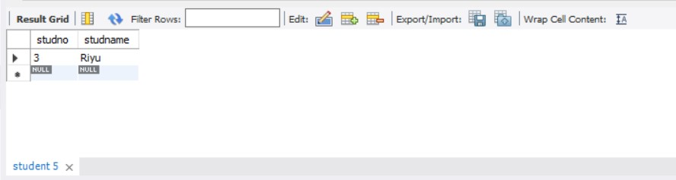



* Delete the failed students.

C:\Users\sukha\OneDrive\Desktop\Telegram Desktop\Activity1\activity1\s_25.jpg

C:\Users\sukha\OneDrive\Desktop\Telegram Desktop\Activity1\activity1\s_26.jpg

* Display activity id and name using object.
* Display student id, faculty id using course name condition with object.

C:\Users\sukha\OneDrive\Desktop\Telegram Desktop\Activity1\activity1\s_27.jpg

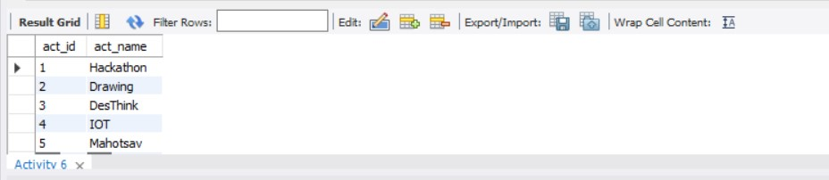

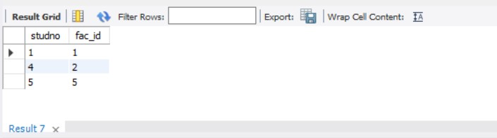

C:\Users\sukha\OneDrive\Desktop\Telegram Desktop\Activity1\activity1\s_30.jpg

* Select department name starting from ‘c’ and faculty name ending with ‘a’.
* Select activity having characters between ‘ck’.

C:\Users\sukha\OneDrive\Desktop\Telegram Desktop\Activity1\activity1\s_31.jpg

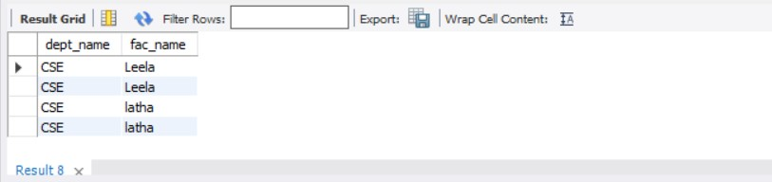

C:\Users\sukha\OneDrive\Desktop\Telegram Desktop\Activity1\activity1\s_34.jpg

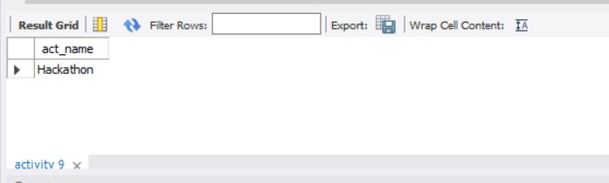

C:\Users\sukha\OneDrive\Desktop\Telegram Desktop\Activity1\activity1\s_34.jpg

* Group by faculty id and display.
* Display the students list whose grade is A using having.
* Display the faculty list who are teaching DM.

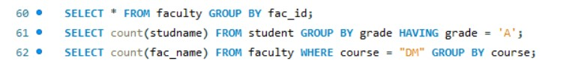

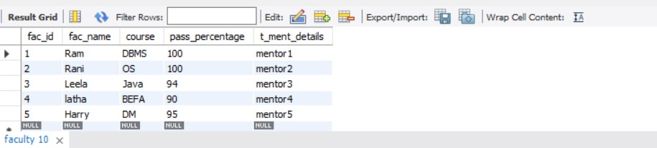

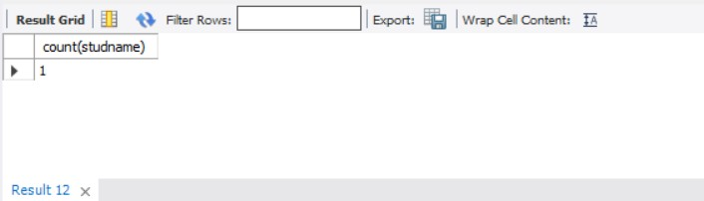

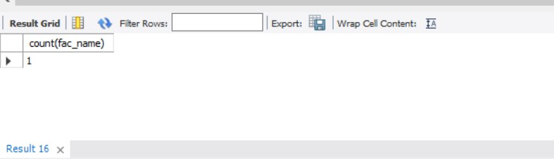



* Apply aggregate functions in student marks - max, min, sum, count, avg.

